## CENTRE WISE COLLECTION

|  |  |
| --- | --- |
| User Name: ……………………………………………. | Trainer Name: Ruchira Ariyasinghe |
| User Sign. : ……………………………………………. | Trainer Sign. : ……………………………………………. |

#### CENTRE WISE COLLECTION

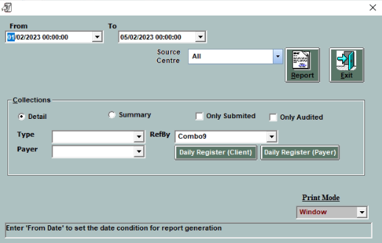

#### Go to Account main menu and select the centre wise collection.

* Select the date criteria
* Click on”All” option to get report for all clients
* Click on”select” to select the particular client.
* Click on ”Detail” to get detailed report as shown below
* Clikc on”summary” for summary report.

